1. Let’s see **ngIf** directive.
2. Directives are typically added by attribute selectors. All **built-in** directives use **attribute selectors**. 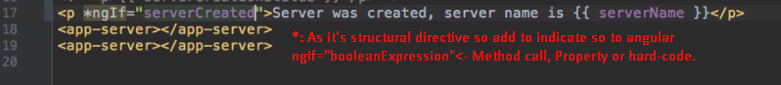
3. Structural Directives: which change the DOM Structure. 